DroneVerse Pillar: Ultimate Guide to FPV Drones for Beginners
Prepared 9 October 2026.

PART A: SEO AND EDITORIAL BRIEF
Field | Recommendation
SEO title (51 characters) | FPV Drones for Beginners: The Complete Starter Guide
Alternate title (57 characters) | Ultimate Guide to FPV Drones for Beginners (2026)
Meta description (about 150 characters) | New to FPV? Learn how FPV drones work, which type to buy first, what gear you need, how to practice safely, and which rules to check.
H1 | Ultimate Guide to FPV Drones for Beginners: Everything You Need to Know
Slug | /ultimate-guide-fpv-drones-beginners/
Canonical | https://[your-domain]/ultimate-guide-fpv-drones-beginners/ (self-referencing; add your real domain)
Primary keyword | FPV drones for beginners
Secondary keywords | beginner FPV drone, what is an FPV drone, FPV drone setup, FPV drone starter kit, FPV goggles, analog vs digital FPV, Tiny Whoop, 5-inch freestyle drone, FPV simulator, Betaflight, ELRS, Angle vs Horizon vs Acro, learn FPV, FPV drone laws
Semantic and related terms | first-person view, flight controller, ESC, brushless motor, VTX, radio transmitter, receiver, LiPo battery, failsafe, arming, bind-and-fly, ready-to-fly
Search intent | Primary: informational. Secondary: beginner buying guidance, learning, setup, safety
Target audience | Complete beginners; camera-drone owners moving to FPV; people choosing between Tiny Whoop, freestyle, racing and cinematic; first-time buyers of drone, radio, goggles, batteries and simulator
Content positioning | The calm, honest entry point to the DroneVerse FPV cluster. It explains the whole ecosystem before the reader spends money, then hands them to a specific guide for each next step. It is not a product roundup.
Featured image | Original illustration: a pilot wearing goggles on one side, a small quad on the other, with a dotted "radio link" and a solid "video link" between them
Featured image alt text | Diagram of an FPV setup showing a pilot with goggles and a radio controller, a small quadcopter, and separate control and video links
Schema | BlogPosting (or Article) with author, datePublished, dateModified, image, and publisher. Add BreadcrumbList. FAQ markup is optional: Google has restricted FAQ rich results to a narrow set of sites, so treat it as a structural aid and don't expect a visible result [VERIFY against current Google documentation]
Editorial voice rules for this piece
- Write like a knowledgeable friend, not a spec sheet.
- No invented crashes, flight hours, test results or "we tested" claims. Where the article gives advice, it says "most pilots find" or "a common approach is," and means it as general guidance.
- No hype words (ultimate, insane, game-changing) in body copy. The title already carries the one "Ultimate" the brief asks for.

PART B: PUBLISH-READY ARTICLE

Ultimate Guide to FPV Drones for Beginners: Everything You Need to Know
Picture yourself in a chair wearing a pair of goggles, and rather than viewing the drone from the ground level, you're seeing through its nose. As the drone banks, the world appears to tilt and the trees grow larger before sliding by. At that point, you're no longer observing the drone; you're inside it. That's what FPV is, and it's a major reason why people become addicted to it. It's also a hobby that has many components: radios, goggles, batteries, firmware, flight modes and local regulations. Beginners generally do not have difficulty with flying itself; instead, they have problems working out what to buy, which things are compatible with one another, and how to prevent breaking the propeller on the first day. The guide acts as a map. Once you've finished reading it, you'll understand how an FPV drone functions, which kind is appropriate for someone who's new to the activity, what a reasonable starter kit should contain, how you can practice without spending a lot of money, and where to find the legal rules applicable in your area.
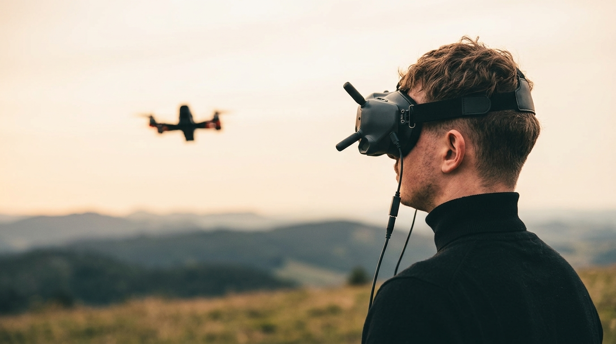
Quick answer: what is an FPV drone?
An FPV (first-person view) drone is a drone with a camera that sends live video to goggles or a screen, so the pilot flies by what the drone "sees." Most FPV drones are flown manually with a handheld radio controller, which gives very direct, responsive control compared with typical camera drones.
Who this guide is for: complete beginners, camera-drone pilots curious about FPV, and anyone comparing Tiny Whoops, freestyle drones, racers and cinematic builds before buying.
In this guide
- What an FPV drone is
- How the parts work together
- Types of FPV drones
- FPV vs camera drones
- What equipment you need
- Analog vs digital video
- Radio systems and ELRS
- What it really costs
- Ready-to-fly vs building
- Simulator training
- Flight modes
- Your first flight
- Safety
- Laws and regulations
- Maintenance and troubleshooting
- Common mistakes
- Buying checklist
- FAQ

1. What Is an FPV Drone?
FPV stands for first-person view. In an FPV setup, a small camera on the drone sends live video to the pilot, who watches it through goggles or a display. The pilot steers using a radio controller.
Four pieces make that work:
- The aircraft, which carries the camera and does the flying.
- The video link, which carries the picture from drone to goggles.
- The control link, which carries your stick movements from radio to drone.
- You, who connect the other three by reacting to what you see.
The most important idea for beginners is that the video link and the control link are two separate systems. The video goes one way, drone to goggles. The control signals go the other way, radio to drone. They use different hardware, and one can fail while the other works fine. We'll come back to this a few times because mixing them up causes a lot of confusion.
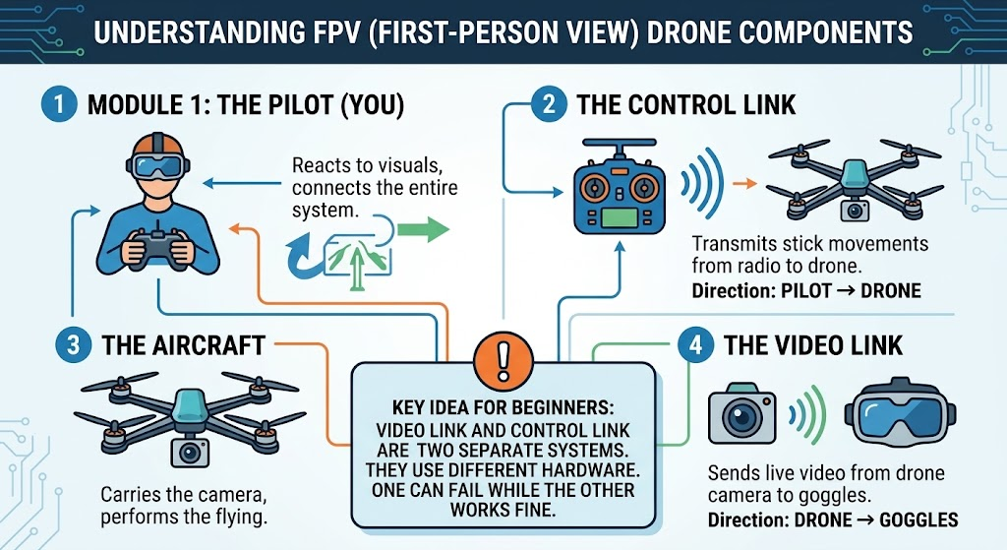

How FPV differs from a typical camera drone

The majority of consumer camera drones are designed with stable aerial photography in mind. These drones are able to hold their position, follow pre-set flight paths, and frequently include obstacle detection. In contrast, an FPV drone is generally built around direct pilot control; although the aircraft is still stabilized by its flight controller, the extent to which flying is left to the pilot will depend on how the drone is set up. We will examine this point in the flight modes section. It's not a general rule. A few FPV-style products have assistance features and some camera drones can be flown more manually. You should always check the specific model.

What people do with FPV
- Freestyle: flowing, acrobatic flying, often outdoors.
- Racing: fast laps through gates or courses.
- Cinematic flying: smooth, dramatic shots, often with a ducted or larger camera-carrying drone.
- Indoor flying: small, light drones in a house or garage where it's lawful and safe.
- Exploration: flying through places that are hard to see from the ground, where it's legal to do so.
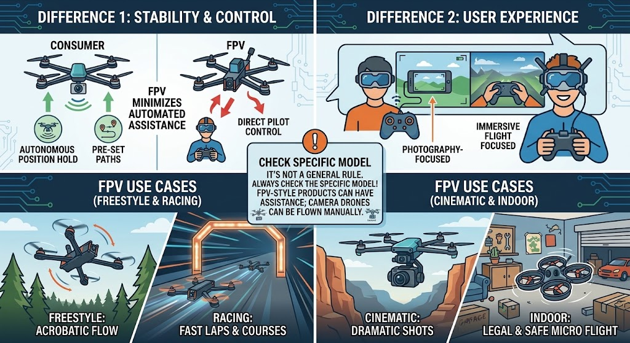

System overview: how signals travel
Control path: Pilot → Radio controller → Receiver on the drone → Flight controller → ESCs → Motors
Video path: Drone camera → Video transmitter (VTX) → Goggles or display → Pilot
Exact layouts vary. Some boards combine the flight controller and ESCs into a single stack, and some digital systems bundle the camera and transmitter. Treat this as the general idea, not a wiring diagram.
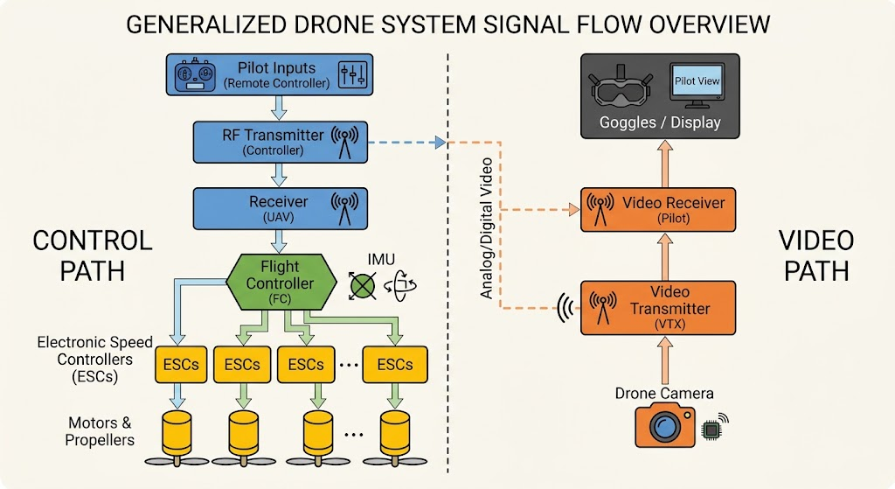

2. How Does an FPV Drone Work?
You don't need to be an engineer to fly FPV, but knowing the parts makes buying, repairing and troubleshooting much less mysterious. Here's the cast, with abbreviations spelled out.

Flight controller
The flight controller (FC) is the drone's brain. It reads sensors (typically a gyroscope, and sometimes an accelerometer) to know how the drone is moving, takes your stick commands from the receiver, and constantly tells the motors how fast to spin so the drone does what you asked.
Without it, a quadcopter couldn't stay in the air for a second. Most FPV drones run firmware such as Betaflight, which you configure on a computer. Other firmware exists, so check what your drone uses.

ESC (electronic speed controller)
The ESC takes instructions from the flight controller and delivers power to the motors, controlling how fast each one spins. A quadcopter has four motors, and each is driven by an ESC channel. They may be on one board (a "4-in-1" ESC) or separate boards.

Brushless motors and propellers
Brushless motors spin the propellers. Their size and rating determine how much thrust the drone can produce. Propellers turn that spin into lift.
Two details matter to beginners. First, motor direction: on a quad, two motors spin clockwise and two counter-clockwise, and propellers must match. Second, propeller choice and motor choice belong together. A mismatch can mean poor performance, heat or damage, which is why you shouldn't swap parts at random.
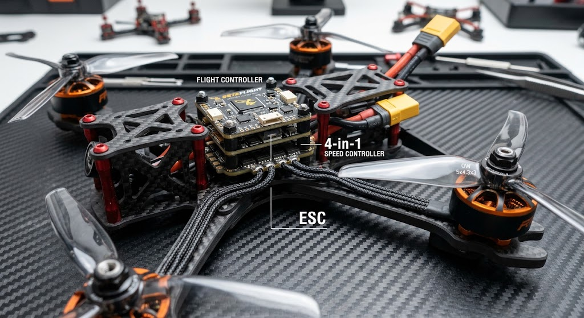

FPV camera
The FPV camera is the one pilots look through. It's chosen for a clear, quick image, not necessarily the prettiest footage. Many pilots add a separate action camera to record higher-quality video. Some digital systems record the pilot's view directly, which we cover in the video section.

VTX (video transmitter)
The VTX sends the camera's picture wirelessly to your goggles. It can be analog or digital, and the two aren't interchangeable. Your goggles need to match.

FPV goggles and displays
Goggles show the live video and put the picture right in front of your eyes. Some pilots use a screen instead, which can be a useful, cheaper way to try things, though it's less immersive.

Radio transmitter and receiver
Your radio transmitter (the controller in your hands) sends commands. The receiver on the drone picks them up and passes them to the flight controller. They have to speak the same protocol, such as ELRS, or the drone won't respond to you.

Battery and power distribution
Most FPV drones use LiPo (lithium polymer) batteries. Two numbers matter most: the number of cells in series (listed as 1S, 4S, 6S and so on), which determines voltage, and the capacity, which affects flight time. Batteries must match what your drone is designed for. Connectors vary too, so check yours before buying anything.
A power distribution board or the ESC board spreads that power to the rest of the drone.

Frame and extras
The frame holds everything together. Frames come in different sizes and materials, and a tougher frame is often easier to repair. Antennas, wiring and optional gear (GPS, buzzers, LEDs) round things out.
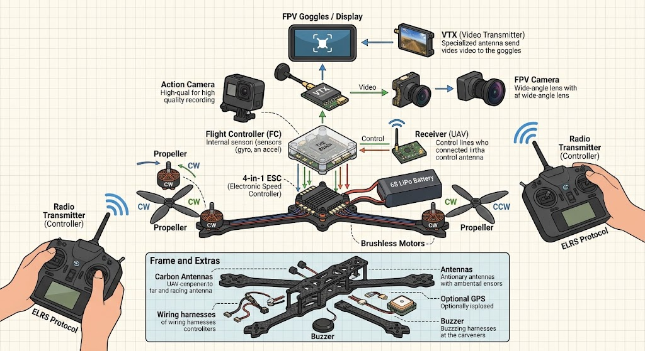
Visual brief: a labeled diagram of a typical quad with all of the above. Note on the image that layouts vary.

3. Types of FPV Drones: Which Is Best for Beginners?
"FPV drone" covers a wide range. Here's what each category is like.

Tiny Whoop
Small, lightweight drones with propellers inside protective ducts. They're designed for flying indoors, and the ducts help protect furniture, walls and the propellers themselves. They're generally forgiving of small crashes, which is great for learning stick control. The trade-off is that they're limited outdoors, especially in wind, and they don't behave like larger drones.

Micro and toothpick drones
Very light drones with open propellers, often outdoors. They can be fun and portable. Because they're light, wind can push them around, and the open props are more exposed.

3-inch and compact freestyle drones
A middle ground: more power and range than a Whoop, easier to carry than a big quad. How suitable they are for a beginner depends heavily on the exact model and where you'll fly.

5-inch freestyle drones
The standard size for freestyle flying. They're fast and powerful, with plenty of room for batteries and cameras. They also take more space, cost more to repair, and punish mistakes harder. Many beginners find them less forgiving as a first aircraft, though plenty learn on them with good simulator practice.

FPV racing drones
Built for speed and agility, and often tuned for racing. They demand fast reactions and a good grasp of acro flying, so they're rarely the best first purchase.

Cinematic FPV drones
Built to carry a camera and produce smooth footage. Some are ducted, smaller "cinewhoop" styles; others are larger. Don't confuse these with stabilized camera drones, which are a different type of product. Cinematic FPV still takes real piloting skill.
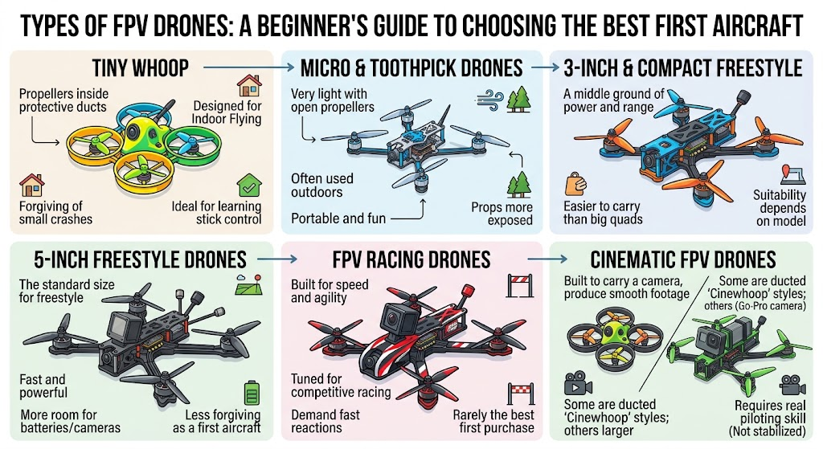

Comparison table
Capabilities and prices vary by exact model, so treat this as typical, not universal.
Type | Typical environment | Beginner suitability | Main advantage | Main drawback | Relative cost
Tiny Whoop | Indoors, calm outdoor days | High | Forgiving, safe practice | Limited outdoors | Generally lower
Micro / toothpick | Outdoors, light wind | Medium | Light, portable | Wind sensitivity, exposed props | Low to moderate
3-inch compact | Outdoors, small spaces | Medium | Portable, capable | Model-dependent handling | Moderate
5-inch freestyle | Open outdoor areas | Lower for first-timers | Power, flexibility, huge parts ecosystem | Less forgiving, costlier crashes | Moderate to higher
Racing | Outdoors, courses | Low | Speed, agility | High skill demand | Moderate to higher
Cinematic | Varies | Medium to low | Smooth footage | Added weight and complexity | Moderate to higher
Cost categories are relative and based on typical market patterns, not verified prices.

So what should a typical beginner choose?
For most people, a small, durable drone paired with simulator practice is a sensible start. A Tiny Whoop-style aircraft is a common recommendation because mistakes are cheap and safe. If you have no indoor space, or you want to fly outside right away, a compact outdoor drone may suit you better, as long as you accept that crashes will cost more.
Go straight to 5-inch if you have open, legal flying space, have put in real simulator hours, and are willing to treat repairs as part of the hobby.

4. FPV vs. Camera Drones: Which Should You Choose?
The two can look similar and feel nothing alike. Capabilities differ a lot between models, so use this as a general guide.
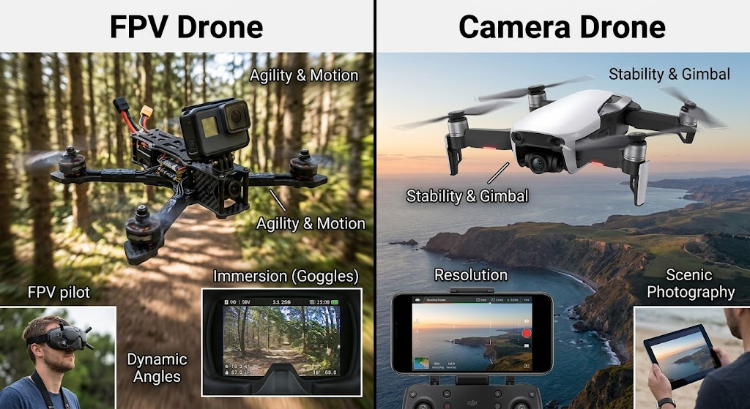
Factor | Typical FPV drone | Typical camera drone
Flying experience | Immersive, through goggles | Watching the drone or a screen
Control | Often direct and manual | Often assisted, with hover and automation
Stabilization and assists | Depends on setup; may be minimal | Usually extensive
Learning curve | Steeper | Gentler
Video quality | Varies; FPV feed is for flying, recording may need extra gear | Typically a primary feature
Durability and repair | Often built to be repaired | Often more integrated and costly to fix
Equipment | Drone, radio, goggles, batteries, charger | Often a ready-to-fly bundle
Relative total cost | Depends on setup | Depends on model
Best for | Thrill, skill, freestyle, expression | Photography, mapping, reliable footage

Decision table
If you mostly want… | Consider…
Steady aerial photos and video with minimal learning | A camera drone
The feeling of flight and a skill to master | FPV
Both, eventually | Start with the one that matches your immediate goal, and add the other later
Cinematic shots with an FPV feel | A dedicated cinematic FPV setup or a ready-made FPV-style product, after checking the learning demands

5. What Equipment Do You Need to Start FPV Flying?
Getting started with FPV flying takes more than just buying a drone. You need a radio controller, FPV goggles, batteries, a charger, and a few basic tools. Most importantly, all your equipment needs to work together. Buying everything based on price alone can leave you with a drone that isn’t compatible with your radio or video system.
Drone
When shopping for FPV drones, you’ll come across a few common terms. The exact package contents can vary by manufacturer, so always check what’s included before buying.
- RTF (Ready-to-Fly): Usually comes assembled and may include most of the equipment you need. However, check whether the package includes a radio controller, goggles, and batteries.
- BNF (Bind-and-Fly): Comes assembled with a receiver, but you’ll need your own radio controller. Make sure your radio is compatible with the receiver.
- PNP (Plug-and-Play): Comes assembled without a receiver, so you’ll need to install one that works with your radio system.
- Kit / DIY: You build and configure the drone yourself using individual components.
Keep in mind that even an RTF package may require some setup or additional purchases. Always check the product details before making a decision.
Radio Controller
Your radio controller is what you use to control your drone, so choose one that feels comfortable in your hands. Make sure it supports the protocol used by your drone’s receiver. ExpressLRS (ELRS) is a popular option among FPV pilots.
It’s also worth choosing a controller with well-documented firmware and good community support. Practising with the same radio in a simulator before your first flight can help you get comfortable with the controls.
FPV Goggles
FPV goggles let you see what your drone’s camera sees while flying. When choosing a pair, consider comfort, image quality, antenna options, and compatibility with your drone’s video system.
Analog and digital video systems aren’t directly cross-compatible, so check compatibility before buying. It’s also a good idea to think about future upgrades. Equipment you can continue using as your skills improve can save you money in the long run.
Batteries and Charger
Choose batteries with the correct cell count, connector, and capacity for your drone. Using an unsuitable battery can affect performance and potentially damage your equipment.
You’ll also need a proper LiPo-compatible charger that supports balance charging. Follow the manufacturer’s instructions for charging, storage, and disposal. Never leave batteries charging unattended, and handle damaged or swollen batteries with appropriate caution.
Spare Propellers and Repair Tools
Crashes happen, especially when you’re learning, so keeping spare propellers on hand is always a good idea. A basic toolkit should include the correct screwdrivers or hex keys, spare propellers, and compatible spare screws.
If you plan to build or repair your own drone, a soldering iron and some basic soldering skills can also be useful. However, not every drone requires soldering for routine maintenance.
Optional but Useful
- Simulator: One of the best investments for beginners, allowing you to practise flying without risking your actual drone.
- Smoke stopper: A useful safety device for DIY builds and repairs that limits current during initial power-up and can help reduce damage from certain electrical faults.
- Battery checker: Helps you monitor battery voltage.
- Protective case: Keeps your equipment organised and protected during transport.
- Spare antennas: Useful if an antenna gets damaged or needs replacing.
- LiPo-safe charging bag: An additional precaution for charging LiPo batteries, although it does not eliminate all fire risks.
You don’t need to buy every accessory right away. Start with the essentials, make sure everything is compatible, and add extra equipment as you gain experience.
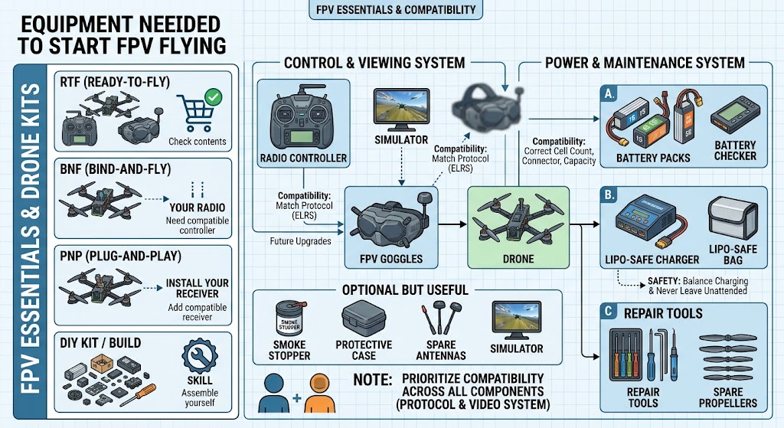

Minimum viable starter kit
- A drone appropriate for your space and skill
- Radio controller matched to the receiver
- Goggles or display matched to the video system
- Correct batteries, charger and a safe place to charge
- Spare propellers
- Basic tools
- Simulator access
- A legal, safe place to practice
- Knowledge of your local rules

6. Analog vs. Digital FPV: Understanding Video Systems
This is one of the first big forks in the road.
Analog FPV has been around longest. It generally has lower equipment cost and a huge selection of compatible gear. When the signal weakens, the picture usually gets noisy and fuzzy, which many pilots find gives them a gradual warning.
Digital FPV offers a sharper picture and, with some systems, built-in recording from the pilot's view. It can cost more, and the weight, power use and behavior when the signal is weak vary by system. Latency characteristics also vary, and differ from analog in ways that depend on the specific product.
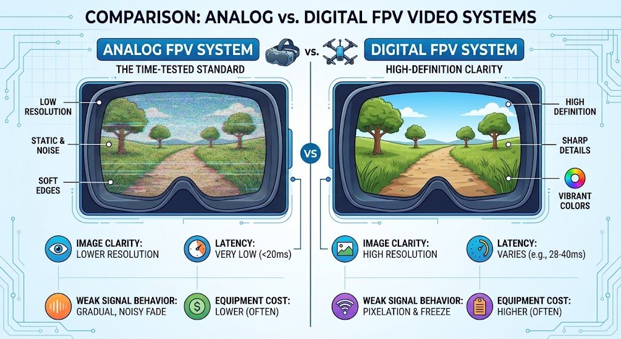
Factor | Analog | Digital
Image clarity | Lower resolution | Typically sharper
Latency | Generally very low | Varies by system
Weak signal | Often a gradual, noisy fade | Varies by system; can break up or freeze
Equipment cost | Often lower | Often higher
Weight and power | Often lighter | Varies
Recording | Usually needs extra gear | Often available, depending on the system
Upgrade path | Wide analog ecosystem | Tied to the chosen digital ecosystem
Real-world results depend upon exact hardware, settings, interference and environment, so there's no clear winner.
A simple guide:
- Analog could be a good fit if you're looking to keep costs low, have more flexibility in your equipment, and fly smaller drones where cost and weight are important factors.
- Digital could be a good fit if image quality and recording ease are priorities, and you have the budget to support this.
In either case, you should purchase an entire ecosystem of products deliberately; goggles, VTX and camera all need to be compatible and supported options are changing, so make sure to check the manufacturer's compatibility information prior to ordering.
Visual brief: An Analog vs Digital infographic showing the same scene rendered in both styles, with a note about compatibility.

7. Radio systems and ELRS explained
Your transmitter sends the positions of your stick to the receiver. The connection between Transmitter and Receiver is called the control link.
ExpressLRS (often shortened to ELRS) is a popular open-source protocol for radio links in use in the FPV ecosystem, often used for its responsiveness and range, and it's supported on many transmitters, receivers, modules and is generally well documented. There are other options, however, and which one you use depends on your transmitter and receiver.
Overview
- Binding: Pairing a receiver to a specific Transmitter or other binding module, so that the receiver only responds to that one. How this is done varies drastically between hardware, consult your hardware's manual.
- Control link and video link: The control link is the link used to send control inputs to the drone, while the video link is a separate link used to send the videostream back to the transmitter. A working video stream does not imply a working control link and vice versa.
- Compatibility: between certain firmware versions on transmitters and receivers, packet rates and hardware is critical to get right for both links. For ELRS, it is important that both ends of the connection are using the same major version of the firmware, consult the projects documentation for specifics.
- Antenna placement: Most antennas have a specific direction they should face, usually not directly against carbon fiber, metal parts such as batteries, or other objects that might interfere with their signal.
- Failsafe: What the drone should do when it loses contact with the control link. This should be set up and tested, as a drone not receiving control inputs from the transmitter will behave unpredictably at best and crash/have serious safety issues at worst.
A successful bind only establishes a connection between your receiver and the binding module. It is important to also set up the failsafe, test the video and antenna placement before flying.
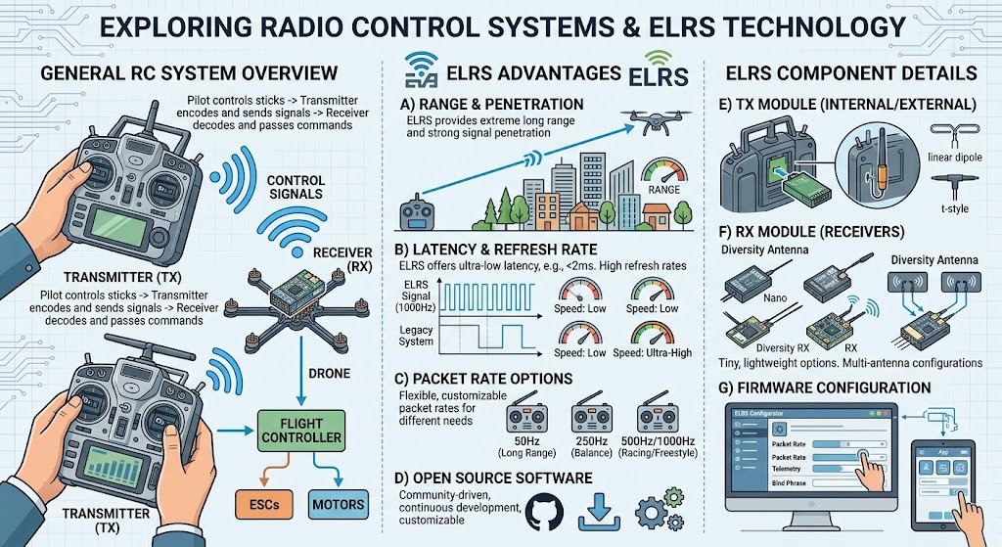
Detailed walkthrough: {{INTERNAL LINK: "how to bind an ELRS receiver" → proposed supporting article}}

8. How Much Does It Cost to Start FPV Flying?
The drone's price tag is only part of the story. The honest way to budget is by total cost of ownership.
We haven't included specific prices here. Prices change often, vary by country and shop, and depend on bundles. Instead, here's what each type of setup typically needs you to account for, so you can price it out against current listings.
Setup | What to budget for
Entry-level indoor | Small drone, a radio, a display or low-cost goggles, small batteries and a charger, spare props, simulator
Beginner outdoor | A compact outdoor drone, radio, goggles, more batteries, charger, spare props and parts, tools, simulator
Digital setup | Everything above, plus a digital-compatible drone and goggles
Advanced freestyle | A larger drone, more batteries, a stronger charger, a stock of spare frames, motors, props and tools
Also budget for replacement parts. Crashes happen, and propellers, arms and antennas are the usual casualties.

What carries over to your next drone
- Often reusable: the radio controller, simulator, charger, tools, and sometimes even the batteries if the next drone uses the same type.
- Often ecosystem-specific: goggles for a specific video system, receivers for a specific protocol, and batteries for a specific size drone.

Avoiding unnecessary spending
Buy the minimum necessary to allow you to fly and practice safely, get the radio and simulator right, and only then invest in accessories that solve a particular need. When looking at price listings, beware of the date, as prices tend to stay listed long after they have changed.

9. Should You Buy Ready-to-Fly or Build Your Own FPV Drone?
 | Ready-to-fly | Bind-and-fly | Self-built
Setup effort | Lowest | Moderate | Highest
Repairability | Depends on design | Depends on design | Usually high, if you built it
Compatibility risk | Lower, if sold as a complete set | Moderate; check receiver protocol | You are responsible for all of it
Initial cost | Varies | Varies | Varies, and often not cheaper at first
Customization | Limited | Moderate | Highest
Learning value | Learn to fly first | Learn to fly and pair | Learn electronics and flying
A ready-to-fly package may require configuration, assembly or additional purchases, so you should read the instructions that come with the equipment.

Who should choose what
- Complete beginners: a ready-to-fly or bind-and-fly package from a manufacturer with good documentation
- Electronics enthusiasts: a bind-and-fly or kit is a good option
- Budget-conscious learners: compare total cost, not sticker price, and spare-part availability
- People looking to build and repair: build, but ideally after you've flown it. It's easier to debug a build if you've had something working already.
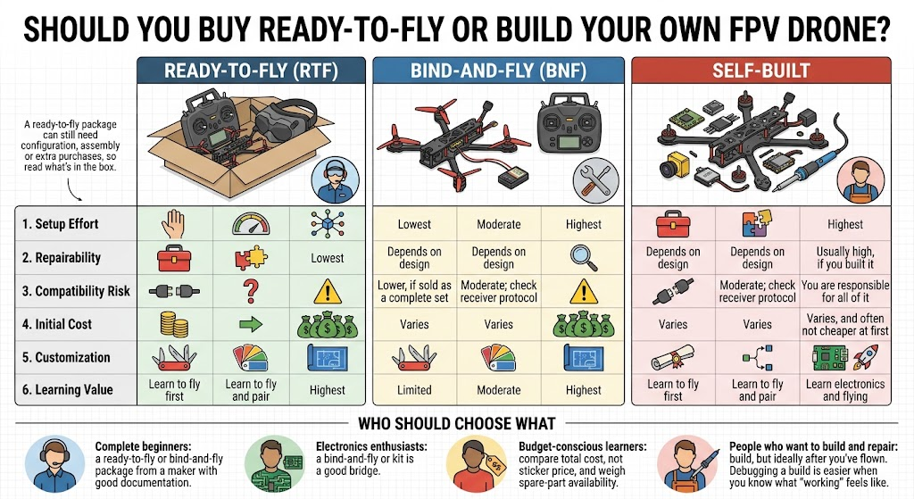

10. Learn FPV Before Flying: Simulator Training

A simulator allows you to crash for free. It's an incredibly powerful tool, and not just because it lets you make silly mistakes without damaging your propellers or having to replace them

What to practice
- Radio setup: learn to bind your radio and get a feel for how the sticks respond.
- Orientation: understanding where the drone is and where it's going to be.
- Throttle control: using the sticks in a manner that produces smooth, small movements.
- Coordinated turns: rolling, pitching, and yawing in unison to make controlled turns.
- Figure eights: a maneuver that teaches you to develop control over the drone.
- Recovery and landing: the landing is the second most important part of any flight.

Simulators let you hone your skills with the sticks, but they don't perfectly recreate the real world. The wind, battery drain, vibration, and signal latency are all different, so your skills will only partially translate.

A milestone-based plan
There's no universally agreed upon set of milestones. You'll have to find what works for you, your aircraft, and your environment. Proceed to the next step only when you're consistently comfortable with the previous one. I've listed some typical milestones below.
- Stick familiarity. Hover and land in Angle mode.
- Basic maneuvers. Fly lines and turn circles in slow, smooth motions in Angle mode.
- Control. Maintain a constant altitude while turning and flying in circles in Angle mode.
- Figure eights in Angle mode at a reasonable speed, then in Horizon mode.
- Introduce Acro in an empty virtual space. Move slowly at first.
- Recover and land from unusual attitudes.
- Fly a similarly sized real-world drone in a suitable location with similarly conservative expectations.
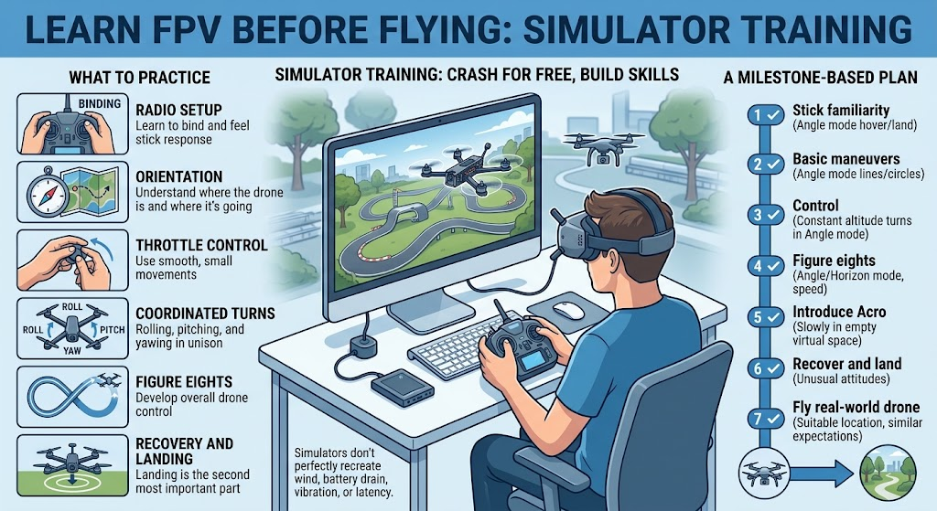
Practice checklist
- Using the radio I'll fly with
- Short, focused sessions
- One new skill at a time
- Finishing every flight with a controlled landing
You're probably ready to progress when… you can fly your current drill repeatedly without panic, recover from mistakes without freezing, and land where you intended.
{{INTERNAL LINK: "FPV simulator training" → proposed/existing supporting article}}

11. Understanding FPV Flight Modes
These names are common in Betaflight. Other flight controllers often use different terms or work differently, and their availability may depend on the configuration.

Angle mode
The drone will self-level. When you release the sticks, it will return to level, and its tilt will be limited. It is the most common mode to start with.

Horizon mode
It will self-level around the center of the sticks and allow you to flip and roll the drone as you move the sticks to the extremes. It depends on the configuration.

Acro mode
The sticks control rotation speed instead of tilt. The drone holds attitude and is more responsive, but it requires practice and is the mode behind most freestyle and racing flying.
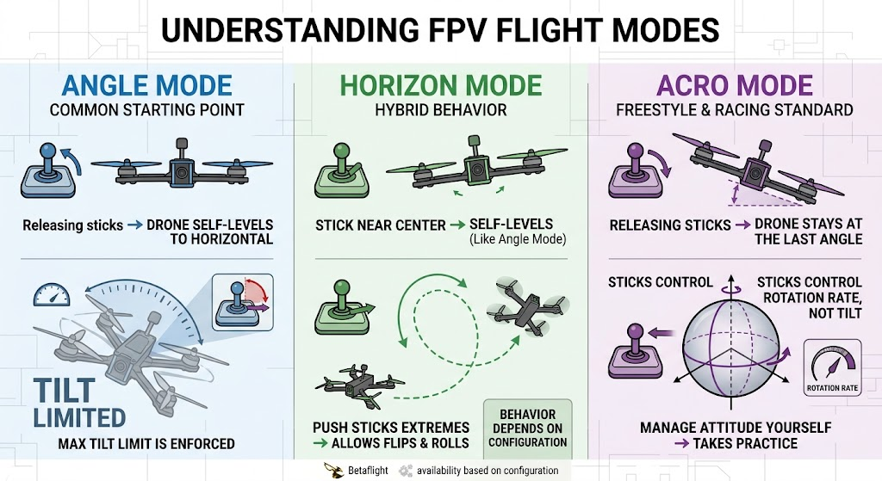
 | Angle | Horizon | Acro
Control behavior | Self-levels, limited tilt | Self-levels near center, free rotation at extremes | Rate-based, no self-leveling
Difficulty | Lowest | Moderate | Highest
Good for | First hovers and basic flying | A bridge between modes | Freestyle, racing, full control
{{INTERNAL LINK: "Angle vs. Horizon vs. Acro mode" → supporting article}}

12. Your First FPV Flight: Step-by-Step Preparation
This is an informative overview only and should not be used as a substitute for your aircraft's manual, appropriate training, or local regulations.
- Review the manuals for the aircraft and batteries.
- Confirm local regulations and select an appropriate venue.
- Visual inspection of the aircraft's airframe, props, motors, antennas and any visible wiring.
- Check condition of aircraft battery or batteries, polarity, type and secure connection.
- Check the control link, correct receiver, operational link integrity and appropriate failsafe configuration.
- Check the video link, picture clarity and channel or settings.
- Check arming status and relevant configuration in the flight controller.
- Remove the propellers prior to bench testing the motor(s) or configurations which may cause accidental motor engagement.
- Install propellers only when ready to fly, in an appropriate location with sufficient clearances.
- Set conservative expectations, select an appropriate area and always have an emergency landing plan in place.

Never fly over people, test failsafe in populated areas, or out of visual line of sight if it is forbidden.
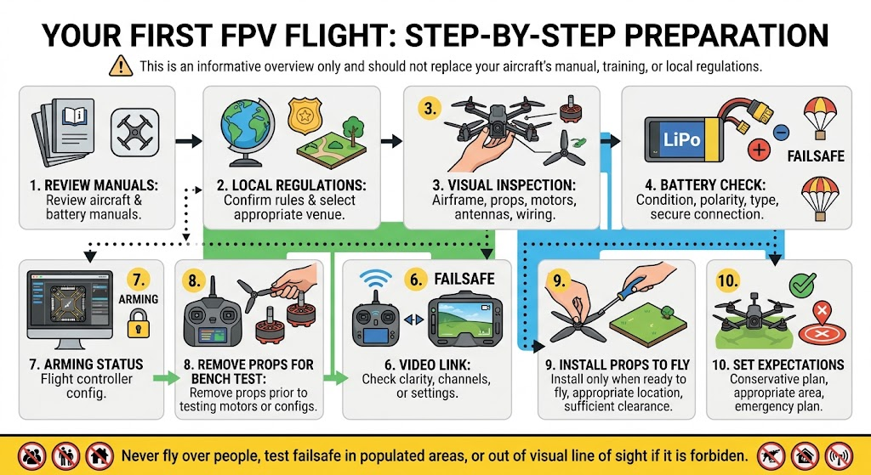
{{INTERNAL LINK: "FPV pre-flight checklist" → existing/proposed article}}

13. Essential FPV Safety Rules
Part of it is based on law and part of it is good practice. That's why we're going to keep the two separate.
  - Propellers are capable of causing severe injuries so make sure that your hands and face remain clear and regard the drone as if it were armed whenever the battery is connected unless the manual states that it doesn't need to be.
  - If LiPo batteries are damaged, mistreated or charged incorrectly they can catch fire; therefore use a charger that is compatible, adhere to the manufacturer's instructions, never leave them to charge unattended and check the batteries before use. Instead of depending on general guidelines, refer to the battery manufacturer's advice on storage and disposal.
  - Conduct the test with the props not attached.
  - Short circuits may damage the components or cause a fire; in the case of new constructions, a smoke stopper can be of some help during the first power-ups.
  - Know what the drone will do if the signal is lost because of radio interference and the fail-safe mechanism.
  - The conditions regarding weather and visibility, such as wind, rain, and poor light, make flying more difficult.
  - Situational awareness: the goggles mask the actual world surrounding you. A number of pilots use a spotter, and in some areas visual observers or a clear line of sight are required. Make sure to check the local regulations.
  - When recording, keep people, wildlife and property safe and give consideration to privacy.
The legal requirements differ from country to country, so make sure to check the regulations in the country you're flying to. As for safety matters, you should adhere to the most up-to-date instructions provided by the manufacturers of your equipment.
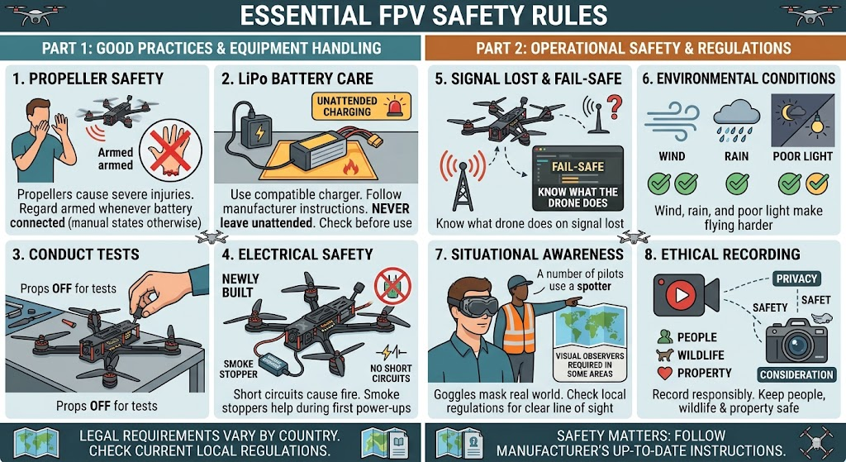

14. FPV Drone Laws and Regulations
There's no global rulebook. Laws depend on where you are, what you fly, how much it weighs, where you fly it and why. Topics that may apply include registration, pilot testing or training, visual line of sight, altitude limits, controlled airspace, flying near people or airports, Remote ID, night flying, commercial use and privacy.
The summaries below are snapshots checked on 9 October 2026. Rules change, so verify with the official source before every new operation or location.

United States (FAA)
Recreational flyers fall under specific rules, and drones that must be registered need to follow the Remote ID rule. The FAA describes ways to comply: a drone with built-in Remote ID, a drone with a Remote ID broadcast module (which requires the pilot to keep the drone in sight), or flying at an FAA-recognized identification area. The FAA's Remote ID page also covers registration and inventory details. Smaller recreational aircraft under 250 grams may be exempt from Remote ID unless registered, according to community summaries, so confirm on the FAA site. [VERIFY with faa.gov]

United Kingdom (CAA)
Since 1 January 2026, a Flyer ID is required for flying a drone of 100g or more, and an Operator ID applies to drones of 100g or more with a camera, as well as to 250g and above. Remote ID is being phased in, with certain requirements starting on 1 January 2026 for class-marked drones, and for many other camera-equipped drones of 100g or more, including privately built ones, from 1 January 2028. Check the CAA for age rules and exceptions. [VERIFY with caa.co.uk]

European Union (EASA)
EU drone rules follow a categories framework administered nationally, so requirements can differ in detail by country. Look up your national aviation authority and EASA's drone pages. [VERIFY]

Bangladesh
This is where an extra caution is needed. Reporting over the past several years shows rules that have changed or been proposed repeatedly, including a "Drone Regulations 2024" draft that would require CAAB licensing and per-flight clearance for most non-toy drones, plus earlier policies and permission requirements. Because the situation has shifted and sources conflict, treat any summary as provisional and confirm directly with the Civil Aviation Authority of Bangladesh before flying. [VERIFY with CAAB, high priority]
Always verify current rules before every new operation or location. This section is a pointer, not legal advice.

15. Basic FPV Maintenance and Troubleshooting
Before any hands-on inspection, disconnect the battery. For bench tests that might spin motors, remove the propellers.
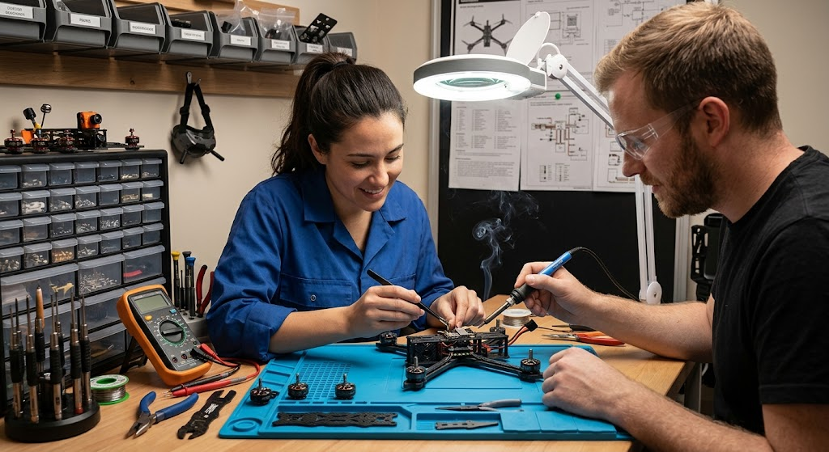
Problem | First safe check | Common cause categories | Stop and investigate if…
Won't arm | Read the arming-status indicators in your configurator | Radio signal, switch setup, sensor or safety flags | You'd have to change many settings to "make it work"
Motor unusually hot | Disconnect, let it cool, and check for bent shafts, loose screws or prop mismatch | Mechanical drag, tuning, wrong prop, damaged motor | It happens again or you smell burning
No video | Check VTX channel, antenna, camera power and goggles settings | Settings mismatch, antenna damage, wiring, power | Something feels hot or smells burnt
Receiver won't bind | Confirm compatible hardware and firmware versions, then follow the binding guide | Mismatched protocol or firmware | You find damaged parts or loose wires
Vibration | Inspect props, motors and mounting | Bent or chipped prop, bent shaft, loose parts | You see cracks or damaged motors
Short flight time | Check battery condition and weight | Aging battery, aggressive flying, wrong prop | The battery is swollen or hot
Damaged prop or frame | Replace damaged parts and check for hidden damage | Crash impact | Cracks near mounting points
Unusual battery behavior | Stop using the battery | Damage, aging, charging problems | Swelling, heat, leaks or smell: treat as a hazard and follow the manufacturer's guidance
Don't change configuration settings blindly, and don't repeatedly power up something that may have an electrical fault.
{{INTERNAL LINKS: "FPV drone won't arm", "FPV drone has no video", "FPV drone motor overheating" → proposed supporting articles}}

16. Common Mistakes New FPV Pilots Should Avoid
Mistake | How to avoid it
Buying incompatible gear | Check protocols and video systems before ordering
Skipping the simulator | Practice there first, with your real radio
Starting with a demanding drone | Choose gentler gear unless you're prepared for the learning curve
Neglecting battery safety | Learn proper charging, storage and inspection
Ignoring local laws | Check rules before every location
Flying in unsuitable places | Pick open, legal, low-risk areas
Not inspecting props and frame | Check every time, before every flight
Changing many settings at once | Change one thing, test, then continue
Assuming video and radio are the same link | Remember they're two separate systems
Buying accessories too early | Wait until you know the problem they solve

17. Beginner FPV Buying Checklist
Before you click "buy," go through these:
- What flying style do I want?
- Indoors, outdoors or both?
- How big and how durable should the drone be?
- Does the receiver protocol match my radio?
- Do my goggles match the video system?
- Do the batteries and charger match the drone?
- Are spare parts easy to find?
- How hard is it to repair?
- Is there good documentation and community support?
- What's the total system cost?
- Is this legal for how I plan to fly it?
If you're… | Consider…
A true beginner with limited space | A small, ducted, indoor-friendly drone plus a simulator
A beginner with open outdoor space | A compact outdoor drone, with simulator practice
A camera-drone pilot wanting immersion | A cinematic FPV or small freestyle drone, after reviewing the learning curve
An electronics fan | A bind-and-fly or kit
Budget-conscious | The smallest compatible system that you can maintain
Affiliate disclosure placement: put the disclosure here and near the top of the article. Suggested wording is in Part F.
Looking at specific kits and gear? Our beginner equipment comparison goes through compatibility and trade-offs in more depth. {{INTERNAL LINK: "beginner FPV equipment comparison" → proposed buying-guide article}}

18. Frequently Asked Questions About FPV Drones
What does FPV stand for? First-person view. The pilot flies using live video from a camera on the drone.
Are FPV drones suitable for complete beginners? Yes, with the right approach. Starting with simulator practice and a forgiving drone makes the learning curve more manageable.
What is the best type of FPV drone for a beginner? There isn't one answer. Small, durable drones suit many first-timers, and your space, budget and goals should decide.
Is a Tiny Whoop good for learning? Often, for stick control and indoor practice. It won't prepare you for everything about larger outdoor drones.
How much does a beginner FPV setup cost? It depends on the drone, the video system and what's included. Budget for the whole system, plus spares, and check current listings.
Do I need goggles to fly an FPV drone? For true FPV flying, you need goggles or a display. Goggles are more immersive, and a screen can be a lower-cost option.
Can I use one radio controller with multiple drones? Usually, yes, as long as each drone's receiver speaks a protocol your radio supports. Each receiver needs to be bound to it.
What's the difference between analog and digital FPV? Analog tends to be cheaper with a wide gear selection. Digital typically offers a sharper picture. Details vary by system.
Is Acro mode difficult to learn? It's harder than Angle at first because the drone doesn't self-level. Most people get comfortable with deliberate practice.
Should I learn in a simulator before flying? It's strongly recommended. It lowers crash costs and builds control skills.
How long does it take to learn FPV? It varies with practice, equipment, instruction and personal circumstances. Focus on milestones rather than a timeline.
Are FPV drones legal? In many places, with conditions. Rules differ by country and by drone, so check your aviation authority.
Are FPV drones difficult to repair? Many are designed to be repaired, though the difficulty depends on the model and your skills.
What is ELRS? ExpressLRS is an open-source radio link used between transmitters and receivers in FPV.
How can I avoid damaging my first drone? Practice in a simulator, start with gentle flying in a safe space, inspect before each flight and keep spare propellers.

Conclusion: Your FPV Journey Starts Here
FPV looks complicated from the outside, but the path is straightforward. Pick a type of drone that fits your space and your budget. Choose compatible gear as one system. Practice in a simulator until the sticks feel natural. Learn the safety basics, and check your local rules before you fly. Then build up in small steps.
You don't have to figure everything out at once. Next, you might read our guides to FPV simulators, flight modes, or beginner equipment, or the troubleshooting guides for when something doesn't work the first time. {{INTERNAL LINKS: see Part D}}

PART C: RESEARCH AND SOURCES
Source | Organization | Claims supported | Checked | Notes
https://www.faa.gov/uas/getting_started/remote_id | FAA | Remote ID compliance paths: standard Remote ID drone, broadcast module (pilot must keep drone in sight), and registration/inventory handling | 9 Oct 2026 | Primary source. Confirm the FRIA path and weight exemption on the FAA site.
https://www.ecfr.gov/current/title-14/chapter-I/subchapter-F/part-89 | eCFR, 14 CFR Part 89 | Regulatory text for Remote ID | Cited by a secondary source (AMA); not opened this session | [VERIFY] Open and confirm.
https://amablog.modelaircraft.org/amagov/?p=7668 | Academy of Model Aeronautics | Under-250g recreational exemption unless registered; FRIA exemption | 9 Oct 2026 | Secondary; confirm against FAA.
https://fpvuk.org/class-marks-and-remote-id/ | FPV UK | UK Flyer ID from 100g; Remote ID dates (2026 for class-marked, 2028 for legacy and home-built camera drones of 100g+) | 9 Oct 2026 | Community organization; confirm on caa.co.uk.
https://www.t3.com/active/outdoors/caa-drone-regulation-changes-2026 and https://www.heliguy.com/blogs/posts/uk-drone-rules-2026-changes/ | T3, Heliguy | Corroborating summaries of the 2026 UK changes | 9 Oct 2026 | Secondary. The CAA page cited by one source: caa.co.uk/drones/getting-started-with-drones-and-model-aircraft/drone-code/getting-what-you-need-to-fly-legally/ [VERIFY]
https://www.thedailystar.net/tech-startup/news/new-drone-regulations-draft-licence-and-clearance-be-mandatory-3751206 | The Daily Star (Bangladesh) | "Drone Regulations 2024" draft: CAAB licensing and per-flight clearance for non-toy drones | 9 Oct 2026 | A draft; final status unknown.
https://www.tbsnews.net/node/109795 | The Business Standard | Earlier CAAB statement requiring written permission ahead of flights | 9 Oct 2026 | Undated in the extract; may be superseded.
https://dfdl.com/publication/drones-regulatory-framework-in-bangladesh-top-5-key-qas | DFDL (law firm) | Drone Registration and Aviation Policy 2020 framework | 9 Oct 2026 | Older; may be superseded.
https://www.easa.europa.eu/en/domains/civil-drones | EASA | General EU drone framework | Not opened this session | [VERIFY] Confirm URL and content.
https://betaflight.com/docs | Betaflight | Angle, Horizon and Acro behavior; failsafe and arming concepts | Not opened this session | Written from general technical knowledge; [VERIFY] against the docs.
https://www.expresslrs.org | ExpressLRS | ELRS overview, binding, version matching | Not opened this session | [VERIFY] before publishing.
Unresolved items for editorial review
- Bangladesh rules conflict across sources and years. Confirm the current status directly with CAAB and rewrite that section from the official text.
- FAA: confirm the under-250g Remote ID wording, recreational flyer requirements and visual observer rules from faa.gov.
- EU: add specifics for at least the countries your readers most commonly live in, from each national authority.
- No product prices or product specs are included, by design. If you add a cost table, add currency, market, date checked and package assumptions.
- Product recommendations and affiliate links are not included, since no specific products were verified.
- Betaflight and ELRS statements should be checked against current documentation, since firmware behavior changes between versions.

PART D: INTERNAL-LINK IMPLEMENTATION PLAN
Per your brief, only use real URLs. Everything below is marked proposed unless you confirm the live URL.
Target | Status | Anchor text | Placement | Why it helps
FPV Hardware, Soldering & Mechanical Troubleshooting (pillar) | Planned: /fpv-hardware-soldering-mechanical-troubleshooting/ per your cluster plan [confirm] | FPV hardware and mechanical troubleshooting guide | Sec. 2 end; Sec. 15 | The next level of depth on parts and repair
Video Transmission (VTX), Goggles & Control Links (hub) | Planned: /fpv-video-vtx-goggles-control-links/ [confirm] | VTX, goggles and control link guides | Sec. 6 | Deeper video and radio coverage
Drone Buying Guides & Reviews (hub) | Proposed | beginner FPV equipment comparison | Sec. 17 CTA; Conclusion | Natural next step for buyers
Batteries, Charging & Maintenance (hub) | Proposed | LiPo battery charging and storage | Sec. 5, 13 | Safety depth
FPV Flight & Pilot Skills (hub) | Proposed | FPV flight and pilot skills | Sec. 10; Conclusion | Learning path
Angle vs. Horizon vs. Acro | Existing in your cluster plan [confirm URL] | Angle vs. Horizon vs. Acro mode | Sec. 11 | Direct expansion
FPV simulator training | Proposed/existing [confirm URL] | FPV simulator training for beginners | Sec. 10 | Reduces crash costs
Tiny Whoop vs. 5-inch FPV | Existing [confirm URL] | Tiny Whoop vs. 5-inch FPV | Sec. 3 | Helps the drone-type decision
Analog vs. digital FPV | Proposed | analog vs. digital FPV | Sec. 6 | Deeper decision help
How to bind an ELRS receiver | Proposed | how to bind an ELRS receiver | Sec. 7 | Keeps procedure out of the pillar
Betaflight setup for beginners | Proposed | Betaflight setup for beginners | Sec. 2 or 12 | Configuration next step
FPV drone motor overheating / has no video / won't arm | Proposed | FPV drone won't arm (etc.) | Sec. 15 | Deep troubleshooting
FPV pre-flight checklist | Existing in your cluster plan [confirm URL] | FPV pre-flight checklist | Sec. 12 | Safety
FPV drone laws, VLOS and Remote ID | Existing [confirm URL] | FPV drone laws and Remote ID | Sec. 14 | Legal depth
Keep it to one link per target in the body, and link each topic at its most relevant section. Avoid linking the same page repeatedly.

PART E: VISUAL PRODUCTION BRIEF
# | Visual | Placement | Required labels | Technical distinctions | Alt text | Type
1 | System overview | Sec. 1 | Pilot, radio, drone, VTX, goggles | Control path vs video path in different colors | Diagram of an FPV system showing pilot, radio controller, drone, video transmitter and goggles | Original illustration
2 | Labeled component diagram | Sec. 2 | FC, ESC, motors, props, camera, VTX, receiver, battery, frame, antennas | Note "layouts vary"; not an exact wiring diagram | Labeled diagram of the main parts of an FPV quadcopter | Original illustration
3 | Control vs video path | Sec. 7 | Transmitter, receiver, FC; camera, VTX, goggles | Two separate arrows in opposite directions | Diagram showing the radio control link and the video link as separate paths | Original illustration
4 | Drone type comparison | Sec. 3 | Tiny Whoop, compact, 5-inch, cinematic | Not to scale unless marked | Side-by-side comparison of four types of FPV drones | Original illustration (or authorized photos)
5 | Analog vs digital | Sec. 6 | Clarity, latency, cost, compatibility | Avoid universal claims | Infographic comparing analog and digital FPV video systems | Original infographic
6 | Starter checklist | Sec. 5 | Each kit item | Show compatibility links | Checklist of equipment needed to start FPV flying | Original graphic
7 | Flight modes | Sec. 11 | Angle, Horizon, Acro | "Betaflight terms" note | Diagram comparing Angle, Horizon and Acro flight modes | Original illustration
8 | Simulator progression | Sec. 10 | Milestones 1 to 7 | No time promises | Step-by-step progression for FPV simulator practice | Original graphic
9 | Pre-flight inspection | Sec. 12 | Props, frame, motors, antennas, battery | Props-off bench note | Pre-flight inspection checklist for an FPV drone | Original graphic
10 | Troubleshooting tree | Sec. 15 | Symptom → first check → stop point | General only | Decision tree for basic FPV troubleshooting | Original diagram

